Modelling cattle in FASSET

Introduction

The animals are either modelled as individuals or as 'super-individuals' (i.e. where a single model animal represents a number of real animals). Although this means that computing time can be much longer than if 'average' animals were modelled, the individual approach was the only realistic option for FASSET. This was partly because the information available as a basis of the model considered animals as individuals, partly because FASSET predicts grass yield and quality with a daily time step. This time resolution demands that the cattle model, unlike the pig model, can respond to short-term changes in the quantity and quality of feed on offer. As this response varies according to the physiological status of the animal and feeds back to the pasture growth, an individual approach was required.

To insure against model or programming errors, the model maintains balances at the animal level for nitrogen and carbon. The dynamics of these balances are described in Section 4 below.

The cattle model consists of two main sections; intake and partitioning of energy and protein.

Intake

The daily intake of an animal (I_{t}; kg DM⁻¹) is calculated using the Danish fill principle (ref), in which the animal is postulated to have a potential daily intake of rumen fill units (RFU). The potential intake of fill units (K_{p}; RFU) is calculated using;

Where lactation number = 1;
otherwise;
k is defined in Eqn and z is defined as;

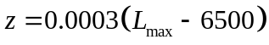

where L_{max} = potential annual milk yield (kg fat corrected).

Each feed is allocated a fill factor (f; RFU (kg DM)⁻¹). For concentrate feeds, this is assigned a value of 0.22. For roughage feeds, f is calculated from;

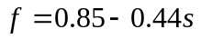

where s is the concentration of digestible energy, expressed in Scandinavian Feed Units (SFU (kg DM)⁻¹). A formal definition of SFUs can be found in ?? but the value for a feed can be approximated as 0.106*(digestible energy (MJ (kg DM)⁻¹) - 5). For concentrate feeds and imported roughage, standard values for s are used, whereas values for home-grown roughage are calculated from the modelled organic matter digestibility.

The Danish intake system includes a reduction k in the potential intake when diet quality is high. In this context, diet quality (q) is defined in terms of RFU (SFU)⁻¹, i.e. a low value indicates a high diet quality. If q ≥0.35, k=1, otherwise, k is given by:

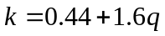

Diet selection

The feedstuffs on offer to an animal are added to the diet in order of decreasing digestibility until the potential intake is achieved i.e. the following is true;

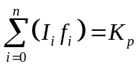

where I_{i} and f_{i} are, respectively, the DM on offer (kg d⁻¹) and fill (RFU (kg DM)⁻¹) of the ith feedstuff. Note that this means that the intake of the final (nth) feedstuff will be ≤ the amount on offer. In the case of barn-fed feedstuffs, the amount on offer corresponds to the ration. Grazing animals are considered to have access to grazable feedstuffs, which enter the diet in the same way as barn-fed feedstuffs. However, the calculation of the amount of feed available is more complex than for barn-fed feedstuffs, where availability is equated to the ration (see Grazing).

After the addition of the jth feedstuff to the diet, the running total intake of fill (F_{j}; RFU) and available energy (S_{j}; SFU) is given by:
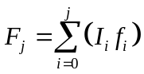
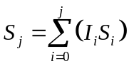

The running diet quality (q_{j}; RFU (SFU)⁻¹) is then given by:

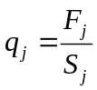

If q_{j}≥0.35 then the intake of the j+1th feedstuff is:
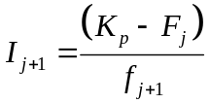
Otherwise, I_{j+1} is found by solving the following quadratic:
If I_{j+1} exceeds the amount of feedstuff on offer then it is equated to this, and the next feedstuff is then considered. The total daily intake of DM (I_{T}; kg) is then:

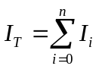

When calculating intake, it is assumed that the rumen-degradable protein in the diet is sufficient that intake is not restricted by the supply of nitrogen to the rumen micro-organisms.

Grazing

During grazing, one or more fields or parts of fields (patches) will be available. The herbage in each patch is considered a separate feedstuff and the amount on offer is calculated as follows;

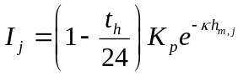

where I_{x} is the potential intake (SFU d⁻¹), t_{h} is the time the animal spends in animal housing (hours per day), h_{m,j} is the herbage mass (t DM ha⁻¹) and κ is a constant. h_{m,j} is calculated as follows:

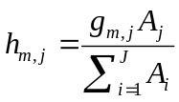

where g_{m,j} and A_{j} are the mass (t DM) and the area (ha) of the jth patch and J is the total number of patches available for grazing. Expressing the herbage mass as a function of the total grazed area allows the availability of small patches to be reduced, to reflect the time the animal must use to search for them. The mass and area of grazable patches is obtained from the crop rotation module in FASSET.

Energy available

The total intake of net energy (S_{I}; SFU d⁻¹) is:
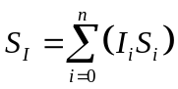

To account for the reduction in availability of net energy that occurs with falling diet digestibility in animals with a high intake, the net energy available for life processes (S_{I}; SFU d⁻¹) is adjusted as follows:
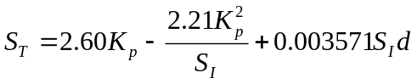
where d is the organic matter digestibility of the diet (as a percentage).

Protein available

The protein available for life processes is calculated using the Danish AAT/PBV system (ref).

The protein degraded in the rumen (P_{d}; gd⁻¹) is given by:
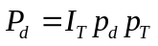

where p_{T} is the concentration of crude protein (g (kg DM)⁻¹) and p_{d} is the proportion of crude protein that is rumen-degradable. Standard values for p_{d} are used for all feeds. Standard values are also used for p_{T} in imported feeds but for home-grown feeds, p_{T} is estimated as 6.25 * total N concentration (g (kg DM)⁻¹).

The capture of N from rumen-degraded protein in rumen microbial protein (g d⁻¹) is calculated as follows:

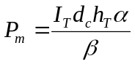
where d_{c} is the digestibility of carbohydrate in the diet, h_{T} is the concentration of carbohydrate in the diet (kg (kg DM)⁻¹) , α is the amino acid synthesis per unit weight of digestible carbohydrate (g kg⁻¹) and β is the concentration of amino acids in microbial protein. d_{c} and h_{T} are obtained from the weighted average of the contributions from the individual feedstuffs in the diets. Standard values are used for the concentrations in the individual feedstuffs.

The protein balance in the rumen (P_{R}; g d⁻¹) is then:
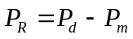

In a departure from the Danish feeding standards, if P_{R} is negative then it is assumed that the N available via recycling is limited to that made available during the fulfilment of the maintenance requirements of the animal (P_{M}; gd⁻¹, see later). In this instance, P_{m}=P_{d}+P_{M};

The amino acids available for life process is then:

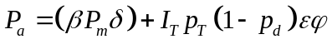

where δ is the digestibility of the amino acids in microbial protein, ε is the prportion of the protein not degraded in the rumen that is digestible and ϕ is the proportion of amino acids in the protein not degraded in the rumen.

Partitioning

Net energy and protein are partitioned between life processes using the factorial approach. Maintenance and pregnancy requirements are always met (or the model stops), whereas the extent to which lactation and growth demands are met is supply-dependent.

Maintenance

The maintenance requirement for net energy (S_{M}; SFU d⁻¹) and amino acids (P_{M}; g d⁻¹) are given by:

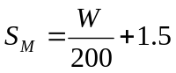
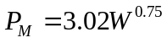

The maintenance requirement for net energy and amino acids must always be met, or the model stops and reports an error.

Pregnancy

The net energy requirement for pregnancy (S_{P}; SFU d⁻¹) is given by:
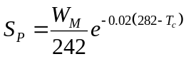
where W_{M} is the mature empty body weight of the animal (kg) and T_{c} are the days before calving.

The pregnancy demand for protein in the Danish system is only specified for the last three months of pregnancy. To enable a more continuous increase in pregnancy demand, the following relationship for the protein demand of the gravid uterus (P_{P}; g d⁻¹) was taken from SCA (1990):
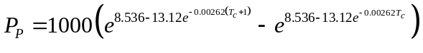
The value of P_{P} is for a cow producing a calf of 40kg birth weight, so was adjusted pro rata to the expected calf weight (0.07*mature empty body weight (kg)).

The pregnancy requirement for net energy and amino acids must always be met, or the model stops and reports an error.

Lactation

Milk production is here considered to be principally limited by energy and protein availability. However, it is also known that the productive capacity of animals that have received a sub-optimal diet in early lactation, is not restored by optimal feeding in late lactation. Consequently, an additional constraint is applied after peak potential lactation, such production can at most be the same as that achieved on the previous day.

The energy supply for lactation is calculated as in SIMCOW (ref). In early lactation, dairy cows will normally support milk production by supplementing the energy from the diet with energy from remobilised body tissue. In late lactation, the balance changes in favour of body growth. SIMCOW includes a function that allows the balance between the competing demands for energy to support milk production and growth to change over the course of a lactation. Firstly, the energy demand for potential milk production on any day (S_{Lpot}; SFU d⁻¹) is calculated:

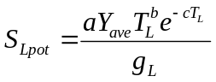

where a, b and c are constants, Y_{ave} is the average potential milk yield over the whole lactation (kg), T_{L} is the time from parturition (d) and g_{m} is the net energy requirement for milk production (SFU (kg fat corrected milk)⁻¹).

Next, the net energy requirement for maximum growth on any day (S_{Gpot}; SFU d⁻¹) is calculated, assuming that the growth increment will be as normal tissue and not fat (see below). The energy available for milk production (S_{L}; SFU d⁻¹) is then calculated as follows:
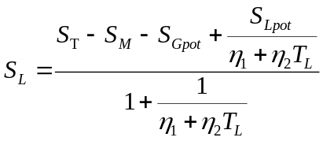

Where η₁ (-) and η₂ (d-1).

The energy-limited daily milk production (Y_{ener}; kg d⁻¹) is then:

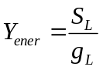
The protein-limited milk production (Y_{prot}; kg d⁻¹) is calculated as:

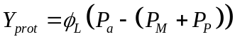

Where φ_{L} is the protein requirement per litre milk (g).

Prior to the time of peak potential lactation, the actual milk production (Y; kg d⁻¹) is then the minimum of Y_{ener} and Y_{prot}. After this time, Y is the minimum of Y_{ener}, Y_{prot} and Y_{t-1}, the milk production on the previous day (kg d⁻¹).

The export of protein in milk is then:

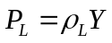

Where ρ_{L} is the concentration of protein in milk (g l⁻¹). φ_{L} > ρ_{L} , meaning that amino acids are used with a lower efficiency for milk production than for growth.

Growth

The extent to which animals support the energy demands for lactation through the remobilisation of body tissue is described above. Body growth is dependent on the availability of net energy and amino acids.

Growth or remobilisation is simulated as in SIMCOW. The potential normal growth is calculated as:

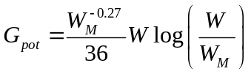

The energy-limited growth (or remobilisation) (G_{ener}; g d⁻¹) is calculated as:

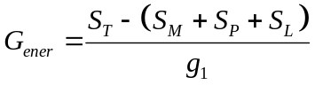 if S_{T}-(S_{M}+ S_{P}+S_{L})<0 or S_{T}-(S_{M}+ S_{P}+S_{L})< g₁G_{pot}

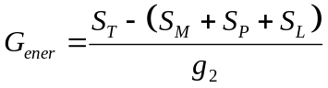 if G_{pot}<0

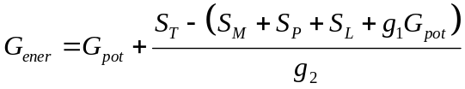 if otherwise.
Where g₁ is the net energy in body weight change during normal growth or remobilisation (SFU (kg empty body weight change)⁻¹) and g₂ is the corresponding value when weight gain occurs via fat deposition.

If G_{ener}<=0 (i.e. remobilisation), G=G_{ener}. If G_{ener}>0, the growth that can be supported by the supply of amino acids is then defined as:

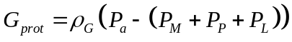

where ρ_{G} is the concentration of protein in body tissue (g (kg empty body weight) ⁻¹). The actual growth achievable is then the minimum of G_{ener} and G_{prot}.

Budgets

Nitrogen

The state variables are the N content of body tissue (N_{Body}; kg).

The model simulates inputs of N in feed (N_{F}) and outputs in dung (N_{D}), urine (N_{U}), milk (N_{M}), calves (N_{Y}), afterbirth (N_{A}) and the change in body protein (N_{G}). All items are in g.

N_{F}, N_{D}, N_{U}, N_{M} and N_{G} are calculated as follows:
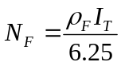

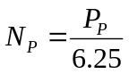

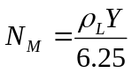

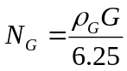

Where ρ_{F} is the concentration of crude protein in the diet (g d⁻¹). N_{D} is calculated from (report 53):

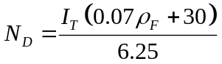

N_{U} is calculated by difference:

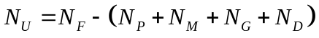

For a pregnant cow, N_{Body} then has the following dynamics:

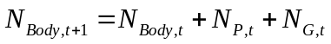

For non-pregnant cows, N_{P} is zero. At the time of calving, the dynamics are:

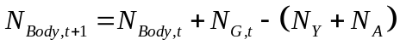

where N_{Y} is calculated as:

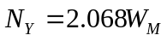

This function is based on the foetus protein content (g kg⁻¹) as defined by SCA (1990), a calf weight that is 7% of the mother’s mature body weight and an assumed concentration of N in protein of 6.25. Using the same logic, N_{A} is then calculated by difference between the gravid uterus and foetus protein contents at full term:

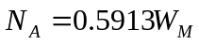

Carbon

Carbon enters the body in feedstuffs (C_{F}), may be retained in body tissue (C_{B}) or may leave in milk (C_{M}), faeces (C_{D}), urine (C_{U}), methane (C_{CH4}) or as CO₂ (C_{CO2}), all in units of g d⁻¹. C_{F} and C_{M} are calculated as:

where the first term is the intake of protein and the remainder are the intakes of fat, cell wall, sugar and starch respectively (g d⁻¹).

C_{F} is calculated using the assumption that only urea is excreted:

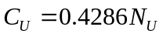

C_{M} is given by:

where σ_{fat} and σ_{lact} are the concentrations of fat and lactose in milk.

C_{D} is calculated as follows:

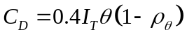

where θ is the organic matter content of the diet (g (kg DM)⁻¹) and ρ_{θ} is the digestibility of that organic matter.

C_{CH4} is calculated using the formula of Kirchgessner et al (1995) and then adjusting for the carbon concentration in methane:

When calculating the carbon retained in body growth (including the gravid uterus), all carbon retained is assumed to exist either as protein or fat. Any given change in body tissue must therefore be resolved into changes in both protein and fat. The dynamics of protein are discussed above. The dynamics of body fat are simulated by making the assumption that all energy is retained as either fat or protein. Assuming further that the metabolisable energy of fat and protein are 39.3 and 23.6 MJ kg⁻¹ respectively, and that one SFU is equivalent to 7.86 MJ (ref), the change in body fat that is associated with any change in empty body weight R (g d⁻¹) can be found from:

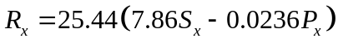

where S_{x} and P_{x} are the net energy and amino acid requirements associated with the change in body weight. C_{B} is then given by:

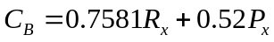

For the special case of calving, the loss of carbon in the calf and in the afterbirth is calculated as for any other change in body growth.

C_{CO2} is calculated by difference:

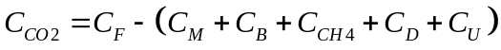

Energy

The reason for considering an energy balance is to estimate the heat production of the animal. Although not necessary to model production or excretion, an estimate of the heat production is necessary for use in modelling ventilation in animal housing.

Energy enters the animal in feed, may be retained in body growth and may leave in milk, faeces, urine, as latent energy (in exhaled air or in sweat) or through sensible heat loss. Here, the balance is simplified by starting with the metabolisable energy in the feed (which is the gross energy – energy lost in faeces). The metabolisable energy in feed consumed can be approximated from the Danish feed tables as:

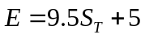

The energy lost in urine (assuming it to be urea, and ignoring the energy in the water) is:

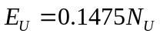

This assumes that urea can be treated as a protein (wrong!)

